**DT228 DT282 Year 2 Databases I Continuous Assessment**

**Case Study for CA Part II 2017/2018**

A lighting shop Linda’s Lighting Emporium offers a design service to clients where they will design a lighting system to the client’s specifications. The shop also sells them the products needed for that system. The shop specialises in all types of lighting – indoor and outdoor, commercial and domestic.

The shop stores details of their clients in the Client table. The shop employs a number of designers and stores details of these designers in the designer table. Details of lighting products stocked by the shop are stored in the product table.

Designers create lighting specifications for clients. Details are stored in the specification table. Clients are charged a commission by the shop for designing the specification. This should cover the cost of paying the designer for the number of hours worked on that specification, also stored, at their hourly rate.

One specification can use one or more products stocked by the shop. Details of the products used are stored in the specProduct table. In addition to the commission charged for designing the specification the final cost to the client includes the prices charged for each product used.

The following constraints apply and must be managed through value constraints:

* Client email addresses must be unique. DONE!!!
* Designer email addresses must be unique. DONE!!!
* All email addresses must contain the @ symbol and a the(.) symbol and these cannot be the first character of the email address. DONE!!!
* Designer rate of pay must be < 75.99. DONE!!!
* Product unit price must be between 5.00 and 45.50. DONE!!!
* The commission price for a specification cannot be more than 16,000. DONE!!!
* The hours worked by a designer on a specification cannot be more than 150. DONE!!!
* Each product is identified by a 1 character product category followed by a 6 digit numeric code. DONE!!!
* Valid product categories are G Garden Lighting, L Lamps & Bulbs, C Cables, S Shades, X Christmas. DONE!!!

The physical design for the database the shop uses is shown below (Note this is available to you as an ERWin file).

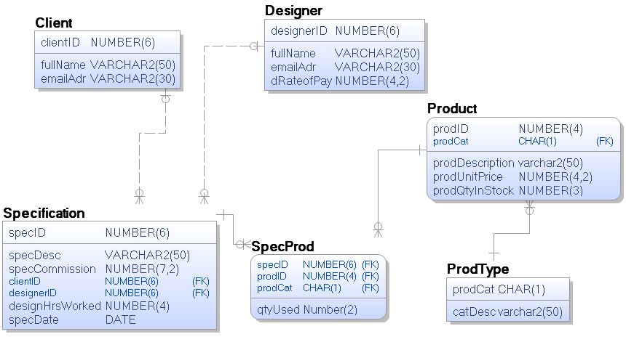

Sample data for Linda’s lighting is included on the next page.

Linda’s Lighting Client List

|  |  |  |
| --- | --- | --- |
| Client ID | Client Name | Client Email Address |
| 101 | J.J. Abrams | [jjab@sw.com](mailto:jjab@sw.com) |
| 201 | Lawrence Kasdan | [lkas@sw.com](mailto:lkas@sw.com) |
| 301 | Daisy Ridley | [drid@sw.com](mailto:drid@sw.com) |
| 401 | John Boyega | jboy@sw.com |

Linda’s Lighting Designer List

|  |  |  |  |
| --- | --- | --- | --- |
| Designer ID | Designer Name | Designer Email Address | Hourly Rate of Pay |
| 101 | Kelly Hoppen | [khop@gmail.com.uk](mailto:khop@gmail.com.uk) | 65.00 |
| 201 | Philippe Starck | [pstark@stark.com](mailto:pstark@stark.com) | 72.50 |
| 301 | Victoria Hagan | [vichag@gmail.com](mailto:vichag@gmail.com) | 75.00 |
| 401 | Marmol Radziner | marmrad@gmail.com | 45.50 |

Linda’s Product List

|  |  |  |  |  |  |
| --- | --- | --- | --- | --- | --- |
| Product Category | | Product ID | Product Description | Product Price | # in stock |
| G | Garden Lighting | 101 | Outdoor Wall Light | 40.00 | 26 |
| G | Garden Lighting | 102 | Patio Lights | 41.00 | 27 |
| L | Lamps and Bulbs | 101 | E14 Engery Saving Bulb | 6.00 | 28 |
| L | Lamps and Bulbs | 102 | E27 Led Bulb | 9.00 | 30 |
| C | Cables | 101 | 2-Core Black Braided Flexible Rubber Cable | 10.00 | 50 |
| C | Cables | 102 | Southwire 250-Ft 2-Conductor Landscape Lighting | 11.00 | 78 |
| X | Christmas | 101 | LED string lights German Christmas 10-light | 15.50 | 55 |
| X | Christmas | 102 | LED heart string lights | 20.00 | 12 |
| S | Shades | 101 | Fabric Cylinder Shade Red | 30.00 | 100 |

Linda’s Recent Specifications

|  |  |  |  |  |  |  |
| --- | --- | --- | --- | --- | --- | --- |
| Specification ID | Client | Designer | Date | Description | Commission Charged | Hrs Worked |
| 101 | 101 | 101 | 12 Jun 2017 | Full house | 10,000 | 10 |
| 102 | 101 | 101 | 14 Jul 2017 | Garden Patio | 12,000 | 20 |
| 103 | 201 | 301 | 15 Aug 2017 | Summerhouse | 8,000 | 5 |
| 104 | 301 | 201 | 10 Sep 2017 | Christmas decorations | 5,000 | 5 |

Products used in Specifications

|  |  |  |
| --- | --- | --- |
| Specification ID | Product Used | #Used |
| 101 | L101 | 20 |
| 101 | L102 | 30 |
| 101 | C101 | 10 |
| 102 | G101 | 20 |
| 102 | G102 | 25 |
| 103 | C101 | 10 |
| 103 | C102 | 3 |
| 104 | X101 | 20 |

Reports Linda’s requires

1. A listing for all designers of the specifications they have worked on including in the output their name, email address and a 10 character description of the specification in uppercase sorted in descending order of designer id and then specification description.
2. A listing of all products. Including one column which combines the product ID and the product category code; the product category description (in uppercase); product description (in uppercase); product price (preceded by the Euro symbol). The listing should be sorted by product category description in ascending order and descending order of product price within each category.
3. A listing of all specifications showing the specification ID, client ID, client name, specification description, specification date (formatted as dd/mm/yyyy) and specification commission(including the Euro symbol) sorted in descending order of commission.
4. A listing of all specifications showing the specification ID, client ID, client name, designer ID, designer name, specification description, specification date (formatted as dd/mm/yyyy) and specification commission(including the Euro symbol) sorted in descending order of commission. the following headers should be used SPECIFICATION ID CLIENT NAME DESIGNER NAME DESCRIPTION COMMISSION DATE COMMISSION AMT
5. A listing for each product used as part of a specification the specification ID, specification description, the product name, product price, number of each product used and a total price per product per specification (price x quantity used).
6. A listing for each specification including the specification ID, specification description and total cost of the specification (commission + Sum of price x product price for all products used).

Hint: Involves a group

1. A listing showing details required for report 6 but including an additional column in the output which categorises the specification as ‘High Value’ if the total cost is > 10,000, ‘Medium Cost’ if the total cost is between 8,000 and 10,000 and ‘Low Cost’ otherwise.

Hint: Involves a selection

1. A listing showing details required for report 6 but including only specifications with a total cost more than 10000. Output should in the form of a sentence for each specification and the output column should be called ‘High Value Specifications’. All numeric fields should be formatted appropriately for numerical/monetary field and trimmed of leading spaces to give a consistent output. E.g.

Specification 102 Garden Patio used a total of 45 products at a cost of €1825.00 and the total cost including commission was €13825.00

Hint: involves a group but including only selected values in the output with all output concatenated.